RESOLUTION NO.__________

RE: CERTIFICATE OF APPROPRIATENESS UNDER THE
PROVISIONS OF THE ACT OF THE PENNSYLVANIA
LEGISLATURE 1961, JUNE 13, P.L. 282 (53
SECTION 8004) AND BETHLEHEM ORDINANCE NO.
3952 AS AMENDED.

WHEREAS, it is proposed to install awnings, replace windows & doors and install ADA ramp at 310 Taylor Street.

NOW, THEREFORE, BE IT RESOLVED by the Council of the City of Bethlehem that a Certificate of Appropriateness is hereby granted for the work.

Sponsored by: (s)

(s)

ADOPTED BY COUNCIL THIS DAY OF

(s)
President of Council

ATTEST:

(s)
City Clerk

HISTORIC CONSERVATION COMMISSION

CASE # 557 – It is proposed to install awnings, replace windows & doors and install ADA ramp at 310 Taylor Street
OWNER/APPLICANT: Stephen & Kathleen Elek / Samuele Masotto

The Commission upon motion by Mr. Evans seconded by Mr. Cornish adopted the proposal that City Council issue a Certificate of Appropriateness for the proposed work described herein:
- The proposal to install awnings, replace windows & doors and install ADA ramp at 310 Taylor Street was presented by Samuele Masotto.
- The new awnings will be fabricated of Sunbrella material and installed above the overhead and main entry doors. They will be 12’ and 5’ wide respectively with open ends and straight valances. There will be no signage on the awnings as requested by the applicant.
- Three of the existing infilled windows will be opened, and new dark bronze aluminum frames and clear glass installed in the existing openings.
- The existing overhead door will be removed and replaced with a new aluminum and glass overhead door with dark bronze anodized aluminum framing with a 5 wide x 4 high window pattern as shown on drawing.
- A wrought iron or painted steel railing system with balusters spaced 4” apart will be installed in front of the overhead door around the new raised platform. The railing height will meet code and be either 36” or 42” high.
- The existing window on the right end of the front façade will be replaced with a new door opening. The existing brick supporting arch will be removed and rebuilt as an arch to create a wider opening for the new front door. The new door and frame will be dark bronze aluminum and the glass in the door clear.
- The sidewalk will be repaired or replaced in-kind with an ADA sloped ramp at the main entrance. The raised platform at the garage door opening will be constructed of concrete.
- Proposed sconce lights and signage will be reviewed at future meeting.
- The motion to approve the proposed work was unanimously approved.

CU: cu
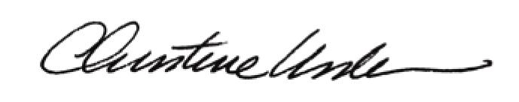

By:

Date of Meeting: July 20, 2015 Title: Historic Officer

